Создание swap на linux сервере.

Проверяем, что swap на сервере отсутствует.
[root@vm-acme-mon02 ~]# swapon -s
Filename Type Size Used Priority
[root@vm-acme-mon02 ~]#

Создаём файл нужного размера, который будет использоваться как swap.
[root@vm-acme-mon02 ~]# dd if=/dev/zero of=/swapfile bs=1M count=2048
2048+0 records in
2048+0 records out
2147483648 bytes (2.1 GB) copied, 3.1697 s, 678 MB/s
[root@vm-acme-mon02 ~]#

Swap-файл должен быть отформатирован под использование swap.
[root@vm-acme-mon02 ~]# mkswap /swapfile
mkswap: /swapfile: warning: don't erase bootbits sectors
on whole disk. Use -f to force.
Setting up swapspace version 1, size = 2097148 KiB
no label, UUID=469793d9-8590-45b9-befe-b77905bc2971
[root@vm-acme-mon02 ~]#

Вносим строчку монтирования swap в /etc/fstab.
echo "/swapfile swap swap defaults 0 0" >> /etc/fstab

[root@vm-acme-mon02 ~]# vim /etc/fstab
…
/swapfile swap swap defaults 0 0

Включаем swap командой которая автоматически ищет swap раздел по данным из /etc/fstab и подключает все найденные swap разделы.
[root@vm-acme-mon02 ~]# swapon -a -v
swapon on /swapfile
swapon: /swapfile: insecure permissions 0644, 0600 suggested.
swapon: /swapfile: found swap signature: version 1, page-size 4, same byte order
swapon: /swapfile: pagesize=4096, swapsize=2147483648, devsize=2147483648
[root@vm-acme-mon02 ~]#

Проверяем, что swap подключился правильно.
[root@vm-acme-mon02 ~]# swapon -s
Filename Type Size Used Priority
/swapfile file 2097148 0 -1
[root@vm-acme-mon02 ~]#

chmod 0600 /swapfile

20170309
https://access.redhat.com/documentation/en-US/Red_Hat_Enterprise_Linux/5/html/Deployment_Guide/s2-swap-creating-file.html

7.2.3. Creating a Swap File
To add a swap file:
- Determine the size of the new swap file in megabytes and multiply by 1024 to determine the number of blocks. For example, the block size of a 64 MB swap file is 65536.
- At a shell prompt as root, type the following command with count being equal to the desired block size:
- dd if=/dev/zero of=/swapfile bs=1024 count=65536
- Change the persmissions of the newly created file:
- chmod 0600 /swapfile
- Setup the swap file with the command:
- mkswap /swapfile
- To enable the swap file immediately but not automatically at boot time:
- swapon /swapfile
- To enable it at boot time, edit /etc/fstab to include the following entry:
- /swapfile swap swap defaults 0 0
- The next time the system boots, it enables the new swap file.
- After adding the new swap file and enabling it, verify it is enabled by viewing the output of the command cat /proc/swaps or free

#
# 20171117
# Below is how to create swap as a separate partition at defined block device.
# https://access.redhat.com/documentation/en-US/Red_Hat_Enterprise_Linux/3/html/System_Administration_Guide/s1-swap-adding.html

# Here is what we have at the begining.
[root@vm-oggcdc02p ~]# lsblk
NAME MAJ:MIN RM SIZE RO TYPE MOUNTPOINT
sr0 11:0 1 1024M 0 rom
sda 8:0 0 150G 0 disk
├─sda1 8:1 0 50G 0 part /
├─sda2 8:2 0 40G 0 part /var
└─sda3 8:3 0 60G 0 part /opt
[root@vm-oggcdc02p ~]#

# After Sergey Khokhlochev added new block device 40GB into this virtual machine.
# We see new block device /dev/sdb.
[root@vm-oggcdc02p ~]# lsblk
NAME MAJ:MIN RM SIZE RO TYPE MOUNTPOINT
sr0 11:0 1 1024M 0 rom
sda 8:0 0 150G 0 disk
├─sda1 8:1 0 50G 0 part /
├─sda2 8:2 0 40G 0 part /var
└─sda3 8:3 0 60G 0 part /opt
sdb 8:16 0 40G 0 disk
[root@vm-oggcdc02p ~]#

# Here I’ve created new partition exactly for swap purposes.
[root@vm-oggcdc02p ~]# parted -s -a optimal /dev/sdb mklabel GPT mkpart primary linux-swap 0% 100% print
Model: VMware Virtual disk (scsi)
Disk /dev/sdb: 42.9GB
Sector size (logical/physical): 512B/512B
Partition Table: gpt

Number Start End Size File system Name Flags
1 1049kB 42.9GB 42.9GB primary

[root@vm-oggcdc02p ~]#

# We can see the new partition appears.
[root@vm-oggcdc02p ~]# lsblk
NAME MAJ:MIN RM SIZE RO TYPE MOUNTPOINT
sr0 11:0 1 1024M 0 rom
sda 8:0 0 150G 0 disk
├─sda1 8:1 0 50G 0 part /
├─sda2 8:2 0 40G 0 part /var
└─sda3 8:3 0 60G 0 part /opt
sdb 8:16 0 40G 0 disk
└─sdb1 8:17 0 40G 0 part
[root@vm-oggcdc02p ~]#

# Format created partition as a swap space.
[root@vm-oggcdc02p ~]# mkswap /dev/sdb1
Setting up swapspace version 1, size = 41940988 KiB
no label, UUID=32f7963d-2cdb-42f1-9fd1-35b44a2eb57b
[root@vm-oggcdc02p ~]#

# Make appropriate record in /etc/fstab
[root@vm-oggcdc02p ~]# vim /etc/fstab
[root@vm-oggcdc02p ~]# tail -n 2 /etc/fstab
UUID=32f7963d-2cdb-42f1-9fd1-35b44a2eb57b swap swap defaults 0 0

[root@vm-oggcdc02p ~]#

# Turn on new swap space.

[root@vm-oggcdc02p ~]# swapon -s
Filename Type Size Used Priority
/swapfile file 2097144 0 -1
/swapfile.1 file 2097144 0 -2
/var/swapfile file 10485752 0 -3
[root@vm-oggcdc02p ~]# swapon -a -v
swapon on /dev/sdb1
swapon: /dev/sdb1: found swap signature: version 1, page-size 4, same byte order
swapon: /dev/sdb1: pagesize=4096, swapsize=42947575808, devsize=42947575808
[root@vm-oggcdc02p ~]# swapon -s
Filename Type Size Used Priority
/swapfile file 2097144 0 -1
/swapfile.1 file 2097144 0 -2
/var/swapfile file 10485752 0 -3
/dev/sdb1 partition 41940984 0 -4
[root@vm-oggcdc02p ~]#

# Turn off already useless swap files.
[root@vm-oggcdc02p ~]# swapoff /swapfile
[root@vm-oggcdc02p ~]# swapoff /swapfile.1
[root@vm-oggcdc02p ~]# swapoff /var/swapfile
[root@vm-oggcdc02p ~]# swapon -s
Filename Type Size Used Priority
/dev/sdb1 partition 41940984 0 -1
[root@vm-oggcdc02p ~]#

# And comment out rows with old swap.
[root@vm-oggcdc02p ~]# vim /etc/fstab

[root@vm-oggcdc02p ~]# grep -e "^#.*swap.*" /etc/fstab
#/swapfile swap swap defaults 0 0
#/swapfile.1 swap swap defaults 0 0
#/var/swapfile swap swap defaults 0 0
[root@vm-oggcdc02p ~]#

# Remove useless swap files.
[root@vm-oggcdc02p ~]# rm /swapfile /swapfile.1 /var/swapfile
rm: remove regular file `/swapfile'? y
rm: remove regular file `/swapfile.1'? y
rm: remove regular file `/var/swapfile'? y

# Below are our results. What swap we have and it’s size.
[root@vm-oggcdc02p ~]# swapon -s
Filename Type Size Used Priority
/dev/sdb1 partition 41940984 0 -1
[root@vm-oggcdc02p ~]# free -g
total used free shared buffers cached
Mem: 62 27 35 0 0 19
-/+ buffers/cache: 7 55
Swap: 39 0 39
[root@vm-oggcdc02p ~]#

2024-12-02 Здесь был момент, где смотрели использует-ли процесс Swap. То есть когда оперативной памяти не достаточно содержимое процесса перемещается в дисковую память - в swap.

https://otus.ru/learning/9209/
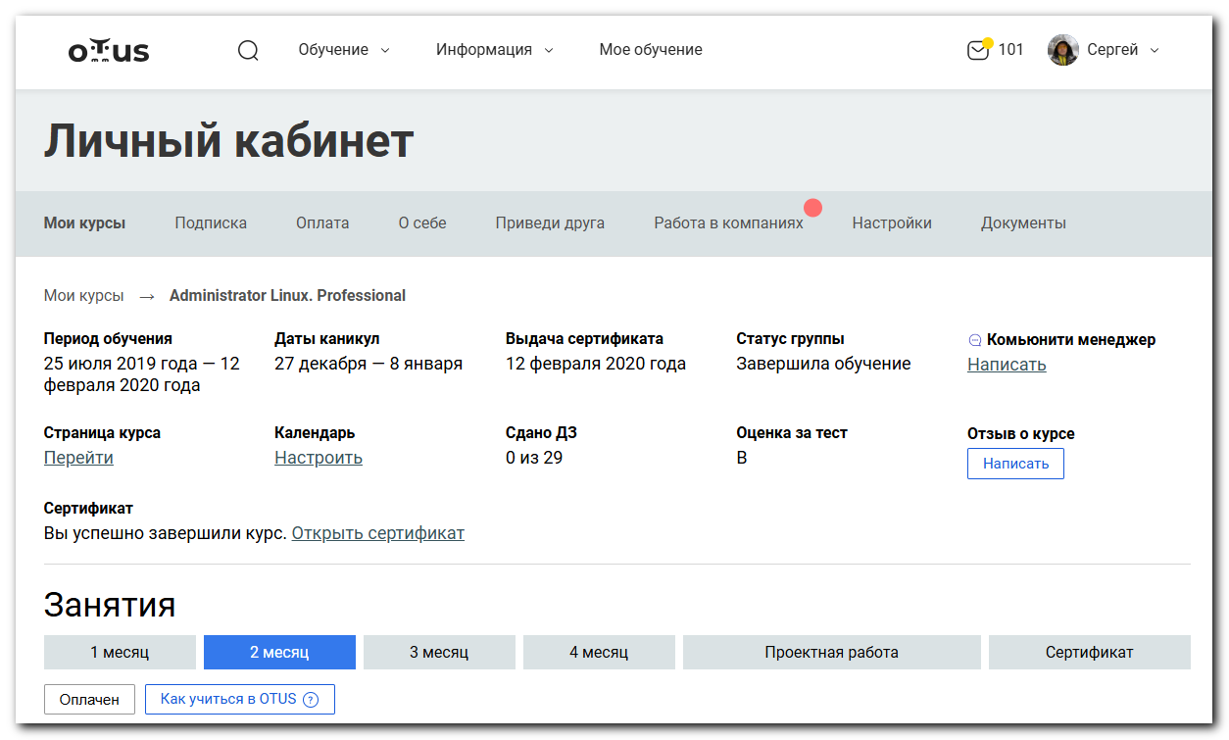
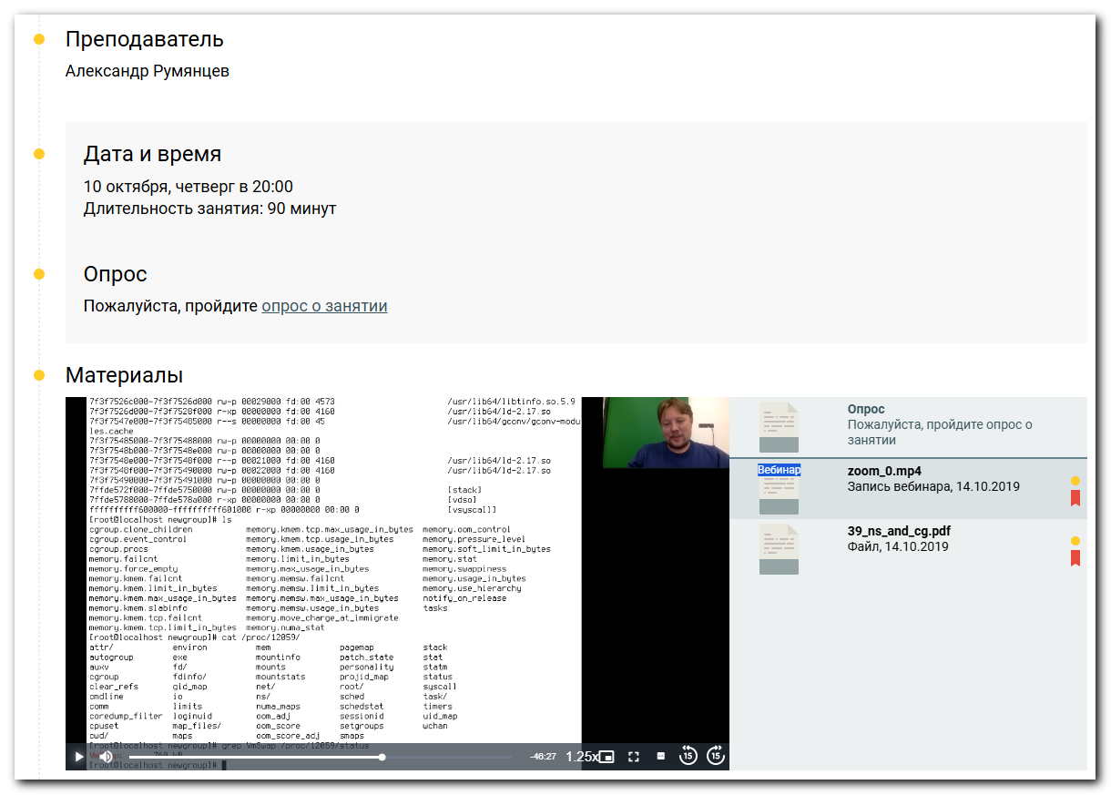
По известному PID процесса проверили наличие строчки в файле состояния процесса.
grep VmSwap /proc/.../status
